Oge by Oge Training Institute nine months syllabus

Basic workroom skills

* TECHNICAL
* Riding the machine
* Knowing your machine
* Sewing of straight line/ curves and zigzag.
* Fixing of Zip
* Types of seams
* Ruler increment
* Bias and Hong Kong seam
* Sewing of Interfacing
* Pockets
* Shirt Collars / Placket

MODULE TWO

* Introduction to skirts/ learning measurement
* Introduction to bodice pattern
* Introduction to sleeves pattern
* Introduction to Trouser pattern

MODULE THREE

* TECHNICAL
* A skirt project
* A blouse project
* A dress project
* A trouser pattern

MODULE FOUR

* SKIRT Variations
* Basic straight skirt block
* Pencil skirt
* Paneled skirt
* Flared skirt
* A line skirt
* Pleated skirt
* Yoke skirt
* Gathered skirt
* Wrap skirt
* Gore skirt/Godet skirt\*
* Trumpet skirt
* Technical

Projects on every variation.

FIRST PROJECT.

DESIGNING A SLEEVELESS DRESS

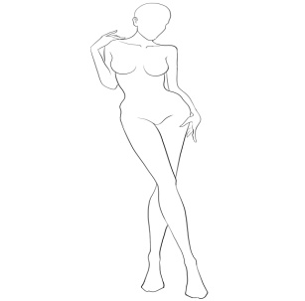

* BODICE PATTERN VARIATIONS
* Princess cut
* Empire cut
* Bustier
* Yoke design
* Wrap front
* Drop shoulder/raglan
* Paneled bodice

MODULE FIVE

* NECKLINE VARIATION
* Cowl neckline
* U neckline
* V-neckline
* Sweetheart neckline
* Square neckline
* Boat neckline
* Round neckline
* Halter neckline
* SLEEVE VARIATIONS
* Bishop sleeve
* Cap sleeve\*
* Fitted sleeve\*
* Short sleeve
* Flare sleeve
* Leg of a mutton
* Sleeves with mock cuff
* Lantern sleeves
* Cowl sleeves

MODULE SIX

* Dart manipulation using pivotal and slash and spread method.
* Mid neck
* C F dart
* Mid armhole
* French
* Waist
* ADVANCED DART MANIPULATION
* Designing with dart (HA 114)
* Tuck dart
* Pleat
* Flare
* Gathers
* MORE DART MANIPULATION
* Double v darts
* Princess cut ending on hip
* Asymmetric curved darts
* Asymmetric darts
* Parallel dart with cape effect

BODICE PATTERN VARIATIONS

* Princess cut
* Empire cut
* Bustier
* Twisted front
* Yoke design
* Drop shoulder/raglan
* Paneled bodice
* TECHNICAL
* SEWING ALL DART

SECOND PROJECT

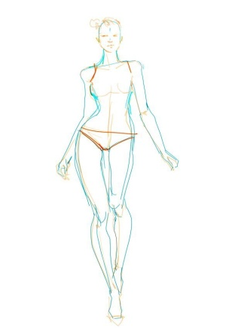

* Designing with Darts.
* Designing a dress with sleeves
* Class project on all variations.

MODULE SEVEN

* BUTTON DOWN SHIRT DESIGN
* INTRODUCTION TO JACKET PATTERNS
* Refer Collar Foundation
* Shawl Collar Foundation
* Low Notch Lapel

MODULE EIGHT

* Trouser Block Variations.
* Straight trouser
* Flared pants
* Box culottes
* Pleated pant
* Penciled pant
* shorts
* JUMPSUIT BASIC BLOCK.
* TECHNICAL

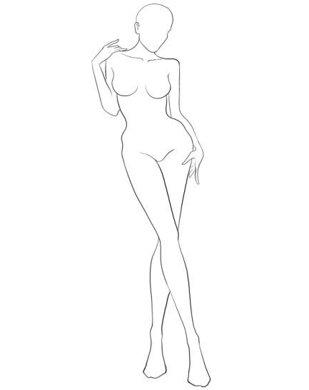

* Designing a jumpsuit
* Designing a Two piece pant and jacket
* Class project on all variations.

MODULE Nine

The flat pattern draping technique.

* Draped cross over blouse
* Twist bodice
* Draped front
* Draped frill collar
* Rever simple cowl collar
* Draped necklines
* Cowl skirt

Module 10

* Strapless foundation and inter construction
* Princess with gathered seams
* Bra top torso
* A slip dress with a slinky skirt
* Technical

Under support for strapless garment

Module 12.

Corset.

* . Overbust
* Underbust
* Cupped corset.

MODULE 12

* Creating a collection.
* Costing your products.
* Simple accounting book keeping tool.

PROJECT

* Design 3 dinner dresses (two English one with African fabric)
* A Suit
* A tailored pant and blouse
* A jumpsuit/ dress.
* Making a basic wedding dress.